IDE Used

IDE: CLion

IDE Version: 2021.2.1

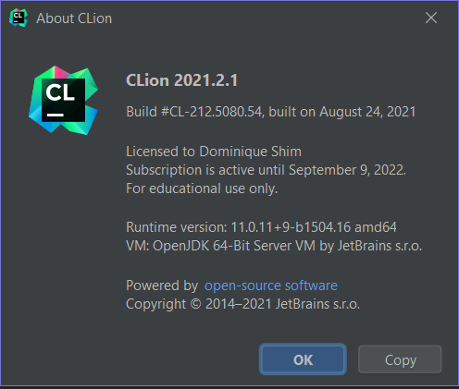

**Environment**

Environment for IDE: MinGW

Compile: G++

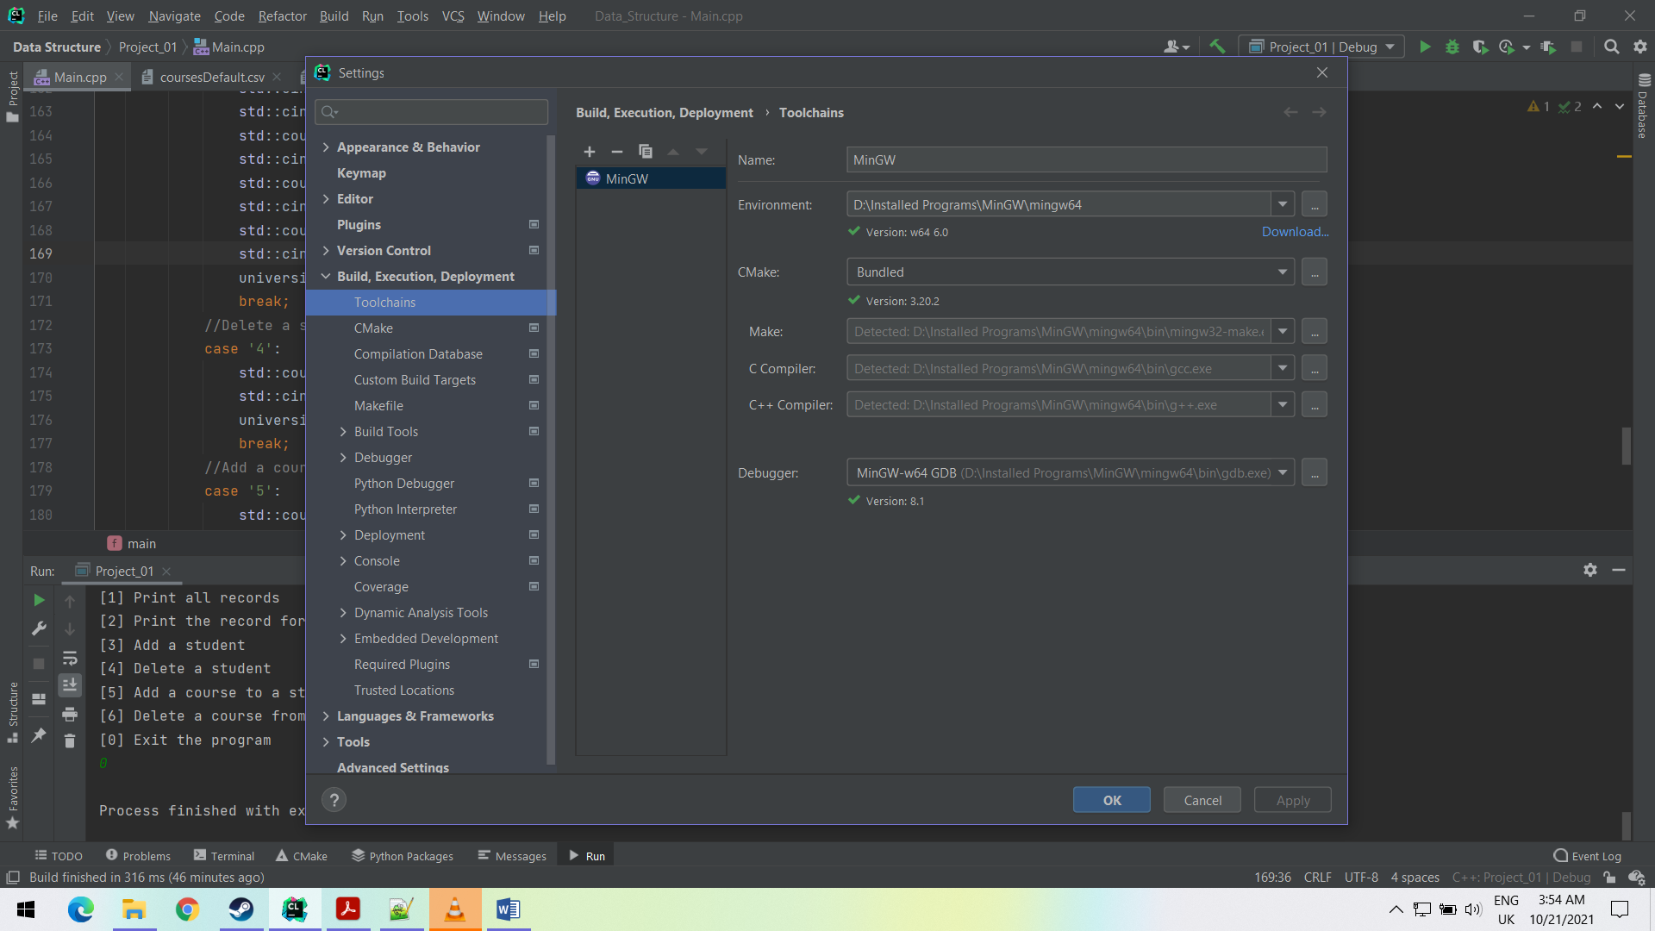

Environment for command line: MinGW

Compiler: gcc

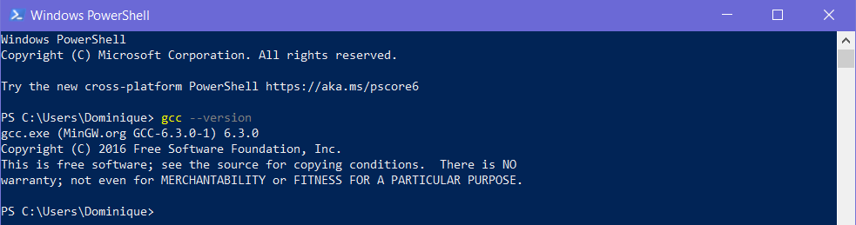

**File Directory**

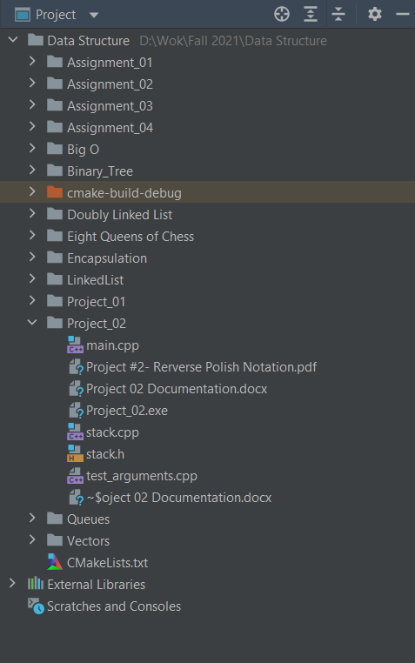

**Testing**

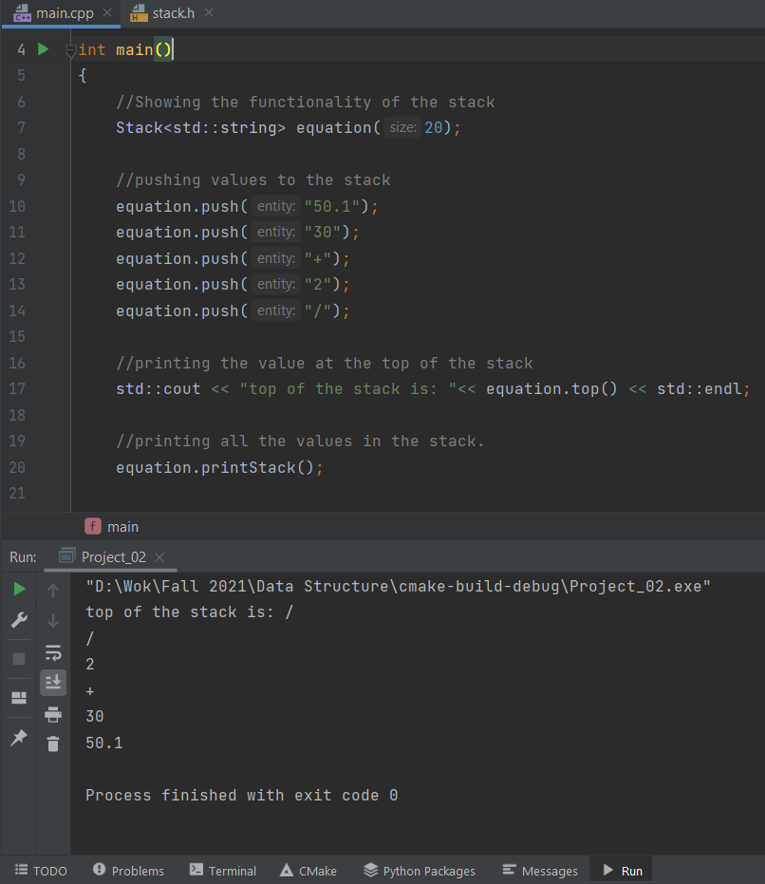

Adding values to the stack and first printing the value at the top then printing all the values in the stack.

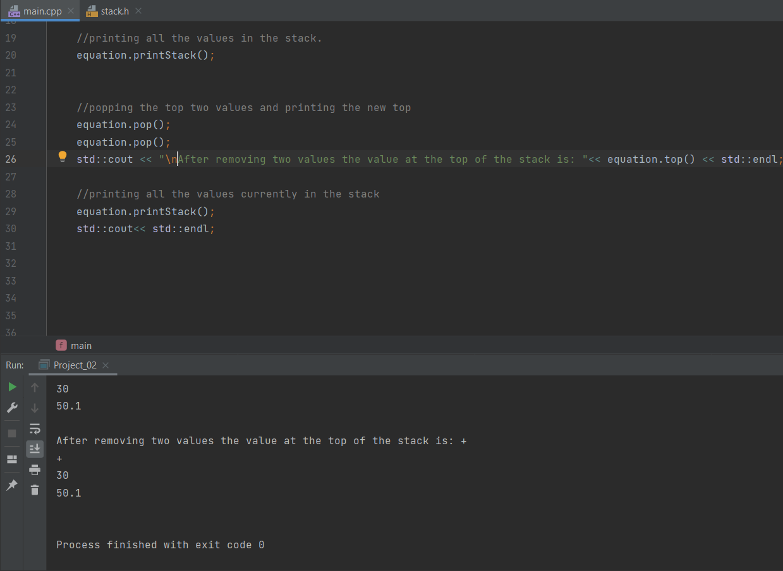

Continuing from the previous instance, pop was called twice and the top value was printing along with all the values in the stack.

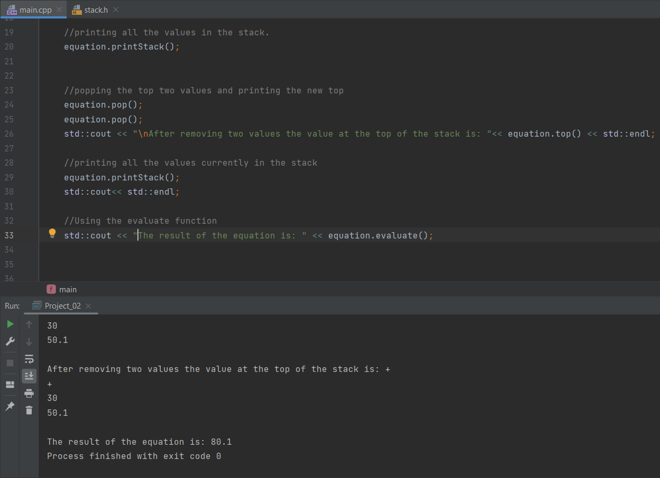

Printing the result after running the evaluate function.

How to Use Command Line to Run Program

Step 1.

Open the command line in the same folder as the files

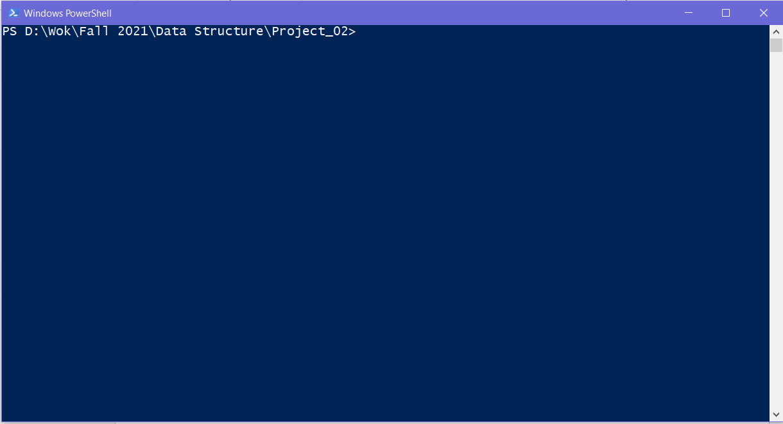

Step 2.

Run the command “g++ test_arguments.cpp -o Project_02.exe” to create an .exe file called Project_02.exe. This file will appear in the folder that the command line is currently located

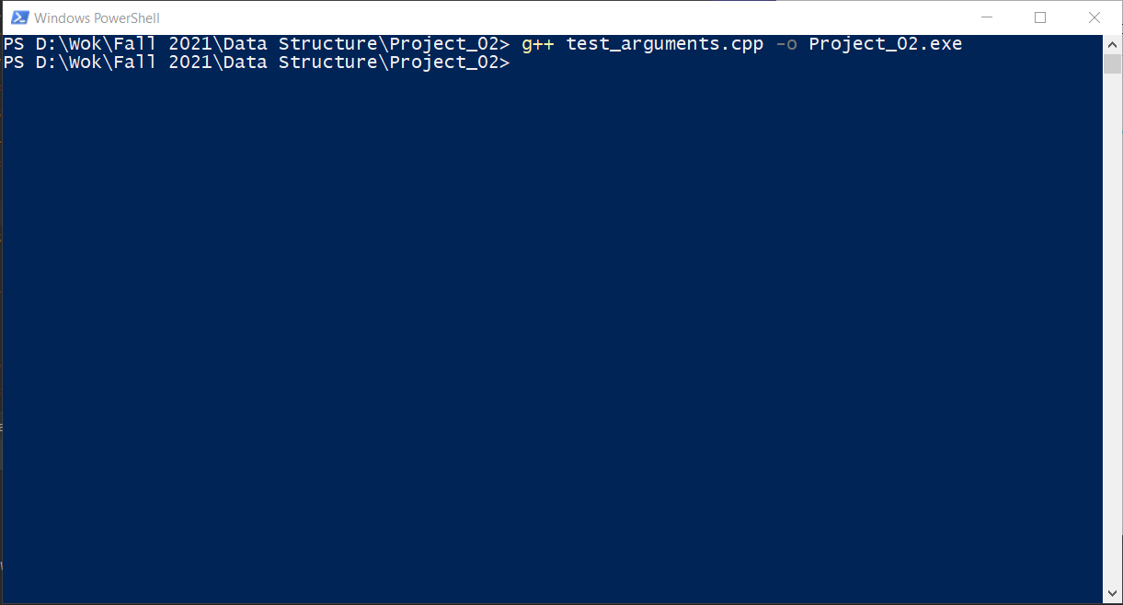

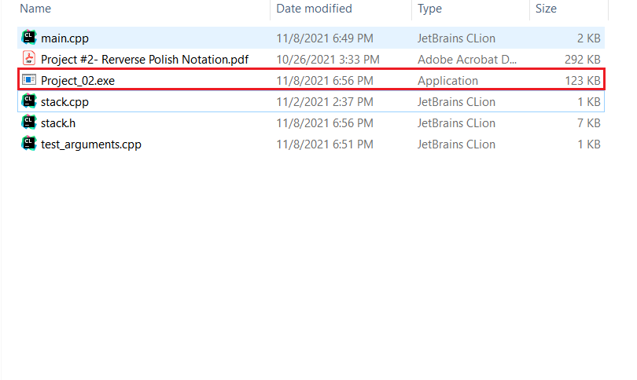

Step 3.

In the command line type “.\Project_02.exe argument1 argument2 … argumentn”. The arguments should be in the order of polish notation.

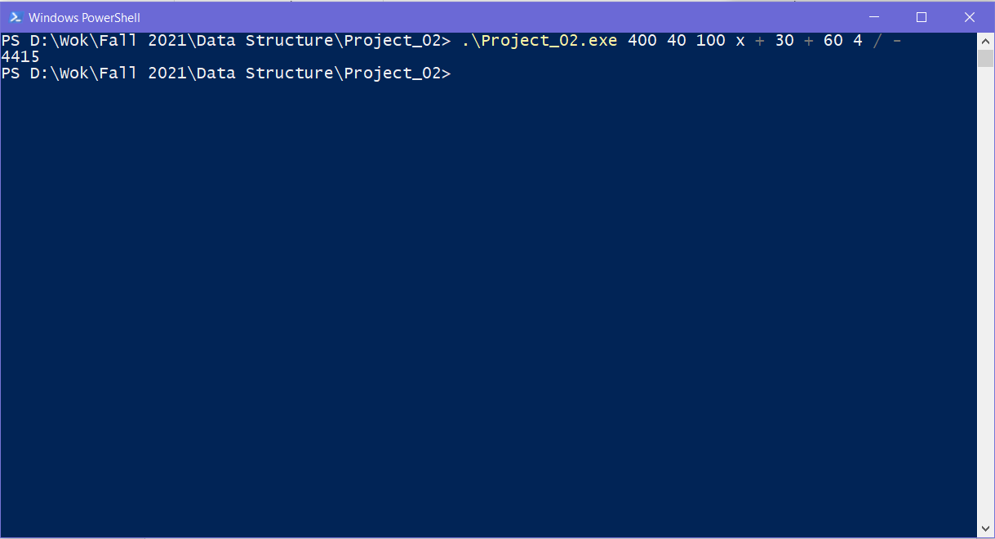

NOTE

When using multiply, use lower case x (x) rather than asterisk (*). Using an asterisk will be treated as a wild card in the command line and return all the file names as an argument